[Max Patch Objective, Ways to Improve and Conclusions]

|  |  |  |
| --- | --- | --- |
| [Masrur Ahmed] | [12-10-2017] | [Professor Pagano] |

# Goal:

CODE: https://pastebin.com/BknQRKa8

GITHUB: https://github.com/ionmasx/ionmasx.github.io/compare/master...DMD-PROJECT?expand=1

## Create an interactive virtual audio system that reacts to music and gives feedback based on how you play with the controller. The overall design is in the form of an orb that reacts to an Xbox controller and all audio input. The feedback and effects can be tweaked in settings.

Demographic: Ages 10-25

1. Ways to improve:

* Clean up code
* Add instruction notes
* Tweak color scheme to modern vibe
* Add new features
* Potentially add using Touch OSC as a feature

### Conclusion:

These revisions will improve the patch by making the overall UX/UI more intuitive while simplifying the learning curve. It will also allow for better design and room for further features.

Dependencies / Credits: Yes, I was the only developer in this instance.

https://www.youtube.com/watch?v=jKnWxlQMy6o

https://cycling74.com/tutorials/making-connections-connecting-a-joystick-to-maxmspjitter

https://docs.cycling74.com/max5/tutorials/max-tut/communicationschapter01.html

Ml Star / ADSR in Package Manager

USER FEEDBACK: Demographic: Female / Age 15

1.    He should make it easier to set up the controller. It’s not completely plug and play.

2.    He can also add instructions on how to add new effects to the ball.

3.    The design is cool but the colors don’t all match up

4.    The orb is really interesting but it doesn’t always react to my music. I have to put it close to my microphone.

5.    It’s pretty fun but he can always add new things. Maybe, he can make it an app that doesn’t need the max app?

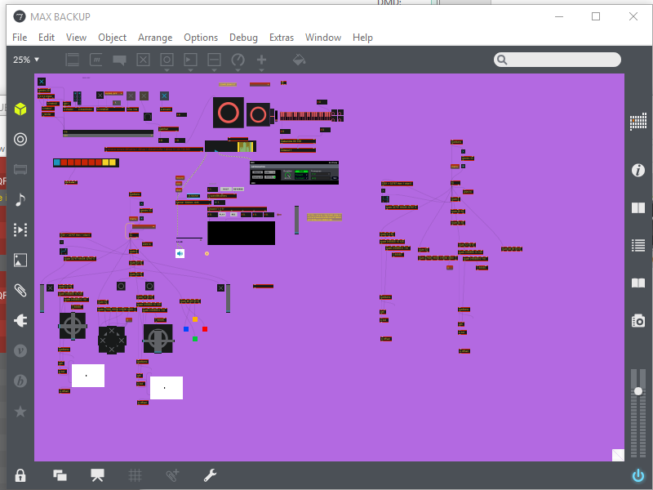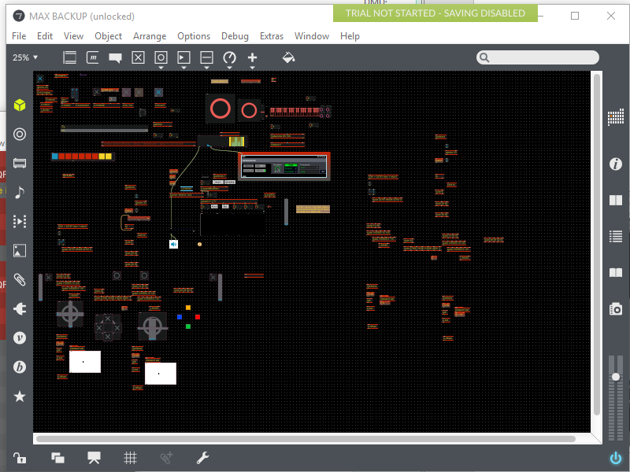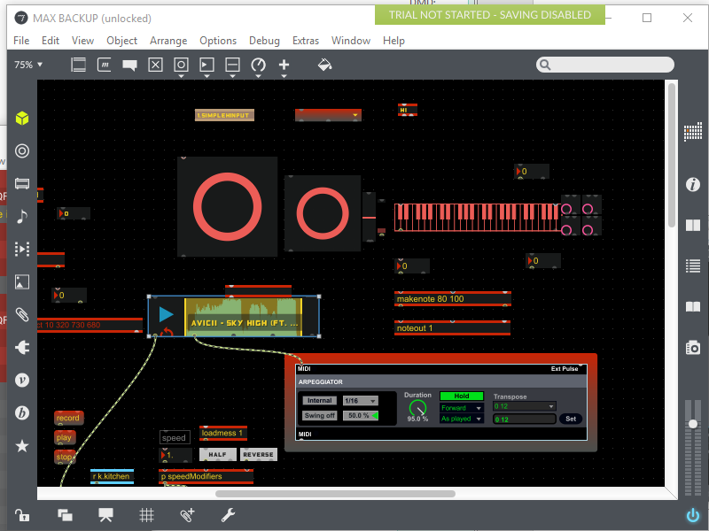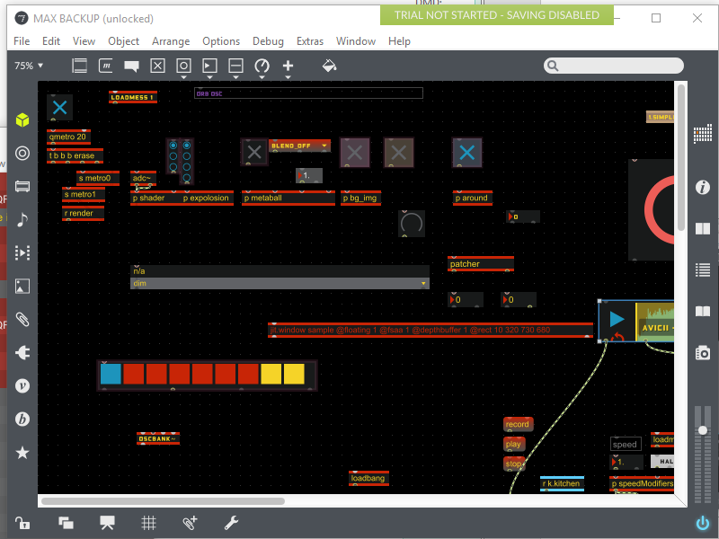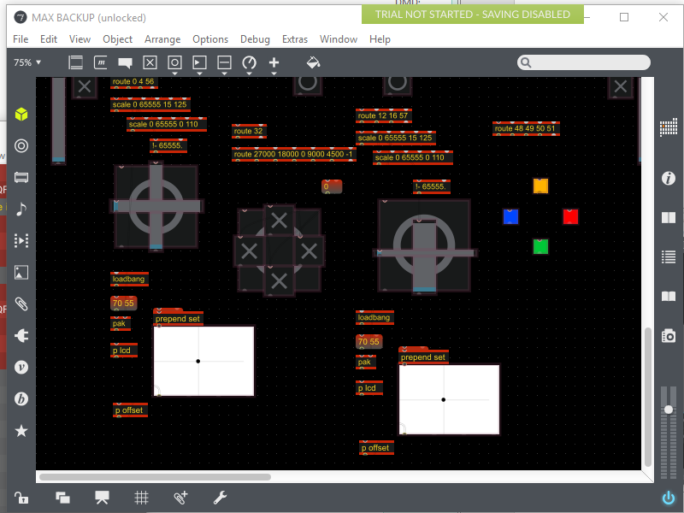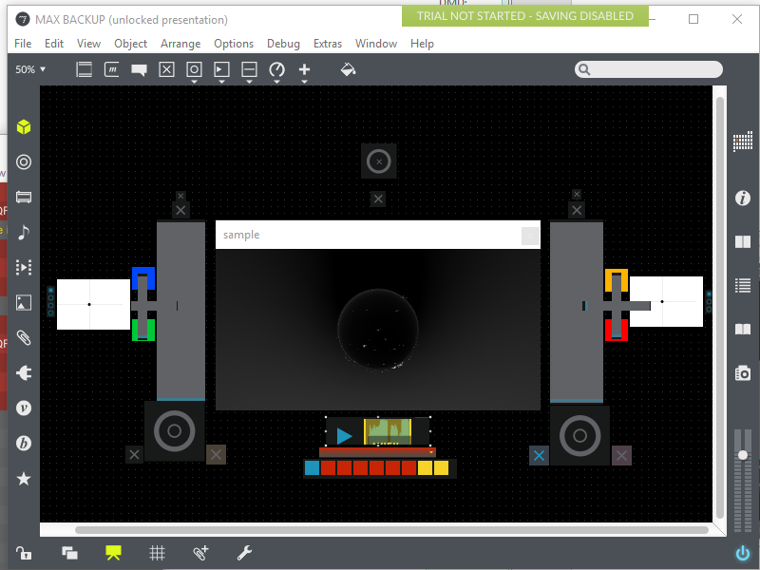

Images: 